account monitoring
from nacm tampa

Our Account Monitoring Service allows you to be alerted when accounts have gone past due, moved scored classes, been reported on for the Flash Report, bankruptcies or trade data. This service is “red flag” that alerts you to check the credit report on your customer. You set the criteria you are interested in...for example, if you want to be alerted when one of your customers is $500 or more past due, in the 60 day column or higher with another member.

This is a one time alert that will stay available for viewing for seven days and updated every Saturday. Once your criterion is entered you can check to see what customers have met the criteria by clicking on the “Account Monitoring” button. This button is found on the menu of options on our website (after you have logged in). This service is included in your membership dues. If you pull the credit report on the customer you have been alerted on, there will be a charge for the credit report.

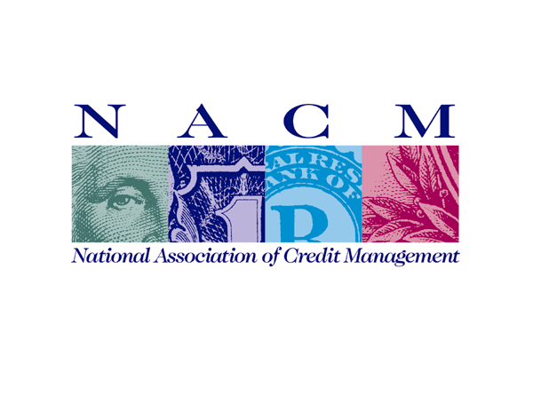
N A C M T a m p a
NACM Tampa
5521 West Cypress Street, Suite 200 ° Tampa, Florida 33607
800.329.6226 ° 813.289.8894 ° fax 813.289.4261
email nacm@nacmtampa.com

Credit Reports include a Credit Score
Credit Reports include a Credit Score
