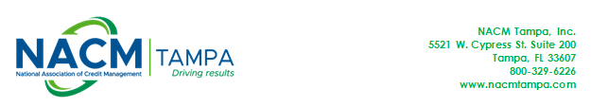
Overview of Florida’s Construction Lien Law by Barry Kalmanson, Esq.
Copyright 2018 – Proceeds of this book will be donated to the ICPC. For more information on the ICPC go to: http://www.nacmtampa.com/page/ICPC.aspx

Chapters Include:

General Scheme of FL’s Construction Lien Law
Lienable Services & Materials
Who is Entitled to a Construction Lien in Florida?
Compliance with FL’s Construction Lien Law
Bonded Projects
Release & Waivers of Lien
Perfecting a Claim by Filing a Lawsuit
Recovery of Attorney’s Fees & Costs
Disciplinary Action & Criminal Penalties

$40.00 including postage

To pay by check: make payable to NACM Tampa Inc and mail to: NACM Tampa Inc, Attn: Joy Bodoh, P O Box 22827, Tampa FL 33622

Or – to have it billed to your NACM Tampa account, check this box and write your member number:
❐ Member Number: _______________________

Or - To Pay by Credit Card, complete the section below and mail to address above or fax to 813.864.9887

❐ MasterCard
❐ Visa
❐ American Express
❐ Discover

Cardholder’s Name__________________________________________________________________________

Cardholder’s Signature_______________________________________________________________________

Account #________________________________________Expiration Date__________________

3 digit security code (or 4 digit for AmEx): _____________________

Credit Card Billing Address including city/state/zip:

______________________________________________________________________________

Please let us know where you would like the book mailed:

Your Name: ___________________________________________________________

Company Name: ________________________________________________________

Address: ______________________________________________________________

City/State/Zip: _________________________________________________________

Email: ________________________________________________________________

