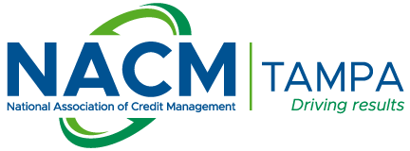
NACM Tampa, Inc.

P.O. Box 22827 • Tampa, Florida 33622
Contact: Cathy Wadley
Phone: 865-546-0452 x107
email: cathy@nacmet.org

D&B REQUEST FORM
To help us expedite your request, please make sure that you fill out all appropriate blanks, then email
this form to Cathy Wadley (contact information above). The charges will be made to your NACM Tampa Account.

Date: _____________________________ Your NACM Tampa Member # ____________________

Your Name: _____________________________________ Your ph#: ___________________________

Your email address: ____________________________________________________________________
Please check mark which report you would like (see next page for report descriptions):
DB-Business Info Report - $102.17
DBC-Comprehensive Report - $148.98
DBB-Business Background Report - $25.57
DBSA-Supplier Analysis Report - $140.60
DBUSA-USA Patriot Act Report - $21.68
DBAS-Advanced Scoring Report - $82.06
DBP-Payment Profile Report - $115.28
DBR-D&B Rating Lookup - $16.00
Please give us the information on the subject who is applying for credit with you:

Company Name: _________________________________________________________________

Address: ________________________________________________________________________

City/State/Zip: ____________________________________________________________________

Phone Number: ____________________________________________________________________

Officer(s) Names and Titles: _________________________________________________________

Officer(s) Names and Titles: _________________________________________________________

Officer(s) Names and Titles: _________________________________________________________
